***Voyage Vista: Illuminating Insights From Uber Expeditionary***

***INTRODUCTION :***

***OVERVIEW:***

***1)*** Uber is a transportation company with an app that allows passengers to hail a ride and drivers to charge fares and get paid. More specifically, Uber is a ridesharing company that hires independent contractors as drivers.

***PURPOSE:***

***2) The Uber mission statement is “to provide transportation as reliable as running water, everywhere, for everyone.” And the Uber vision statement is “to ignite opportunity by setting the world in motion.”***

Uber links passengers with drivers using the Uber app. Generally, the drivers own their own car. The company does also offer rental or lease on cars through third party partners like Hertz, Get Around and Fair. UberFleet is an app for those managing squads of drivers.

***PROBLEM DEFINITION AND DESIGN THINKING***

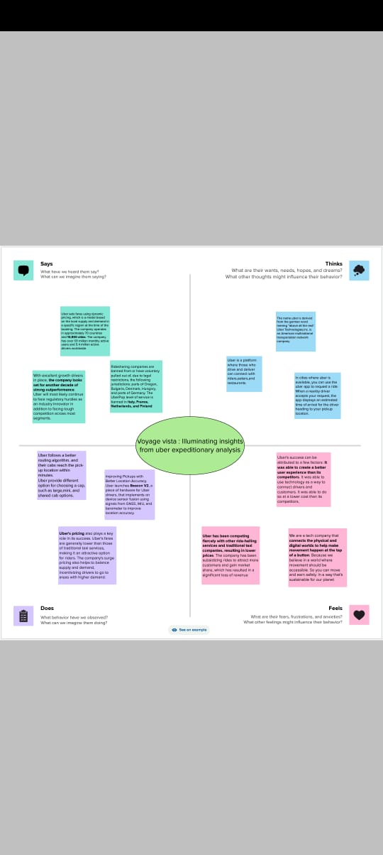

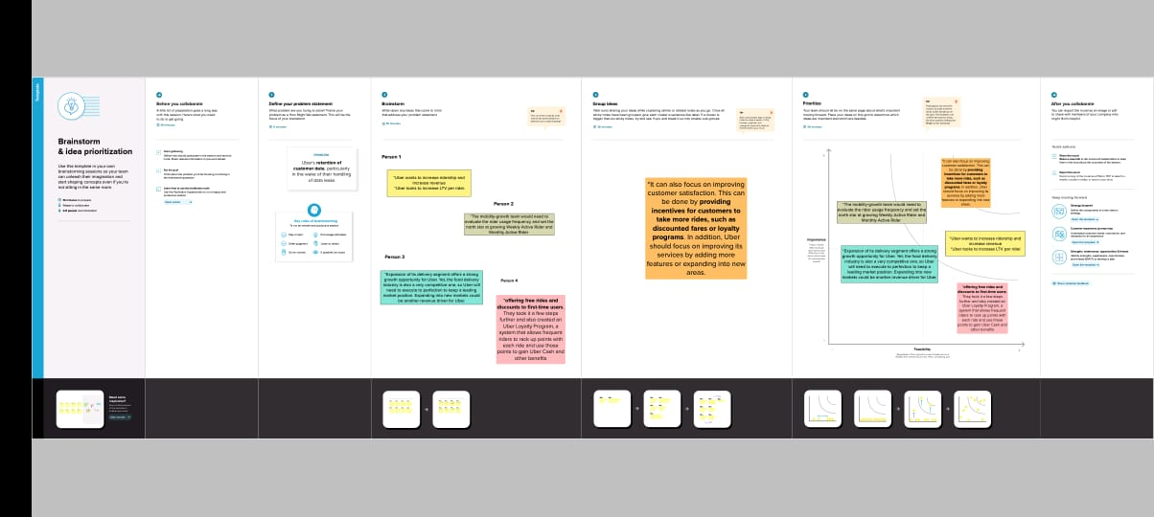

***RESULT***

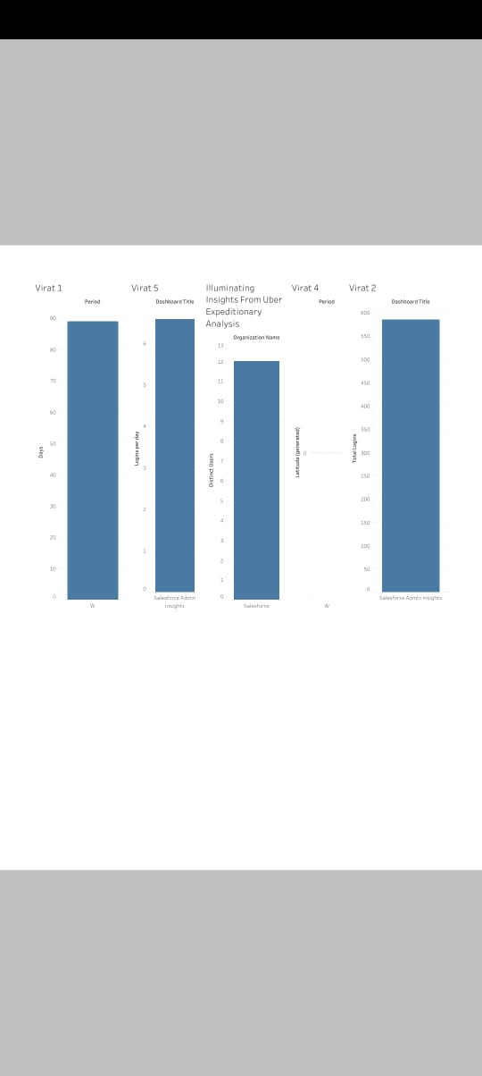

ADVANTAGES:

1.Uber's advantages include door-to-door convenience, safety, and reliable quality

2. Fast Trips Any Time, Almost Anywhere - While wait times vary, Uber customers typically spend far less time waiting than customers of traditional taxi services.

3. Uber offers more competitive perks and ways to save money.

4. Uber has become a prime example of the gig economy at work

5.The pros of being an Uber driver include having the freedom to pick your hours, meeting new people, and earning some income

**DISADVANTAGE:**

**1.Uber's disadvantages include its surge pricing and the negative effects of replacing steady jobs with gig work.**

**2.The company has disrupted taxicab businesses and allegedly caused an increase in traffic congestion**

**3.Air Pollution: Transportation is a major contributor to air pollution**

**4.Congestion: Traffic congestion is a common problem in cities and densely populated areas.**

**APPLICATION:**

**The Uber app is a great way to make your travel plans stress-free. Request a trip on demand or schedule one ahead of time**

**The Uber app provides convenient and affordable transport in the city. Communication between passengers and drivers is done via the app.**

**CONCLUSION:**

**Uber Technologies, Inc. (commonly referred to as Uber) provides ride-hailing services, food delivery, and freight transport. It is headquartered in San Francisco and operates in approximately 70 countries and 10,500 cities worldwide.**

**FUTURE SCOPE:**

**As part of the launch of Uber Green in June, it will add 25,000 electric cars on its platform in partnership with fleet providers like Lithium, Everest and Moove, the company said on Wednesday. Besides, it will roll out 10,000 electric two-wheelers in Delhi by 2024 along with Zypp Electric, another EV start-up.**

**APPENDIX:**

**https://public.tableau.com/views/SFAdminInsightsOrgView-Demo_16959938996510/Dashboard5?:language=en-US&publish=yes&:display_count=n&:origin=viz_share_link**